JARPN/JARPN II research results
The first phase of the Japanese Whale Research Program under Special Permit in the North Pacific (JARPN) was conducted between 1994 and 1999. The JARPN had two main objectives: a) determine the stock structure of common minke whale, and in particular to investigate whether or not the “W” stock exists and if so to estimate mixing rates between “O” and “W” stocks, and b) determine the feeding ecology of the common minke whale in the North Pacific.
The International Whaling Commission Scientific Committee (IWC SC) carried out a workshop in February 2000 to review the data and results of JARPN (http://www.icrwhale.org/eng/workshop.pdf). This report concluded that:
"the Workshop noted that ... information obtained during JARPN had been and will continue to be used in the refinement of Implementation Simulation Trials for the North Pacific Minke whales, and consequently was relevant to their management".
Based on the results of JARPN, in 2000 Japan began a new and expanded program called JARPN II.
The ongoing JARPN II started with two feasibility surveys in 2000 and 2001. The first full survey started in 2002. The objectives of the JARPN II are the following: a) feeding ecology and ecosystem studies (prey consumption by cetaceans, prey preference of cetaceans, ecosystem modeling); b) monitoring environmental pollutant in cetaceans and the marine ecosystem (pattern of accumulation of pollutants in cetaceans, bioaccumulation process of pollutants through the food chain, relationships between chemical pollutants and cetacean health), and c) stock structure of large whales (common minke whale, Bryde’s whale, sei whale and sperm whale).
In January 2009 the IWC SC carried out a review of the data and results collected by JARPN II in its six first years (2002-2007).
Scientific Contributions from JARPN/JARPNII appear in different forms, such as scientific documents for the IWC/SC meetings*¹, as publications in peer reviewed journals*², and as oral presentations at scientific symposia.
JARPN/JARPNII sample/data have also been used in undergraduate, master and doctoral theses, chapters of books, and the ICR quarterly bulletin (Geiken Tsushin) and the Suisan Shigen Kanri Danwakaihou annals.
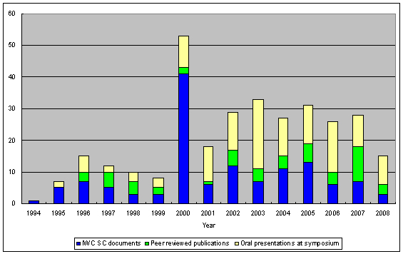
Figure 1: Scientific contributions from JARPN/JARPN II shown as the number of published papers in peer review journals, scientific documents presented to the IWC Scientific Committee and oral presentations at symposiums and congresses.
The larger number of contributions in 2000 is coincident with the review of the JARPN programme carried out by the IWC Scientific Committee.
All the data and samples obtained by JARPN/JARPNII have been available to the national and international scientific community through established data access protocols. JARPN data sets are here: http://www.icrwhale.org/pdf/JARPNdata.pdf. The data access protocol of ICR is at: http://www.icrwhale.org/pdf/Appendix2.pdf, which can also be found at the IWC SC web page: http://www.iwcoffice.org/sci_com/data_availability.htm#protocols.

*¹ http://www.icrwhale.org/JARPNSCpaper.htm
*² http://www.icrwhale.org/JARPNpaper.htm

