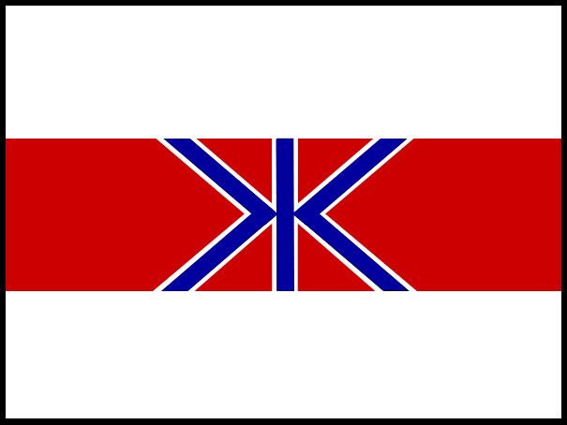
FISHERIES AGENCY
OPENING STATEMENT
OPENING STATEMENT
MINISTRY OF AGRICULTURE, FORESTRY AND FISHERIES, GOVERNMENT OF JAPAN

2-1, 1-Chome, Kasumigaseki, Chiyoda-ku, Tokyo 100, Japan TEL:03-3502-8111 EXT:

OPENING STATEMENT OF JAPAN
58th ANNUAL MEETING

INTERNATIONAL WHALING COMMISSION

The Government of Japan expresses its appreciation to the Government of St. Kitts and Nevis for hosting the 58th Annual Meeting of the IWC and for the hospitality we have received. We are pleased to be here on your beautiful island of St. Kitts.

This 58th Annual Meeting marks a serious turning point for the IWC.

The IWC has become dysfunctional because of fundamental differences in the position of its members. It has become a mere stage for emotional and political conflicts at the sacrifice of the original mission of the organization: conservation and sustainable use of whale resources.

Japan, together with other members supporting the sustainable use of whale resources have great concerns about this situation and expressed their commitment to normalizing and saving the IWC as a resource management organization. We are convinced that the IWC can only be saved from its current crisis by respect for and good faith interpretation of the International Convention for the Regulation of Whaling (ICRW). This means protecting endangered and depleted species while allowing the sustainable utilization of abundant species under a controlled, transparent and science-based management regime.

Since the adoption of the moratorium in 1982, the IWC has failed to meet its objective as mandated by the ICRW; that is, “to provide for the proper conservation of whale stocks and thus make possible the orderly development of the whaling industry”. Now, after 14 years of discussion and negotiations to complete a Revised Management Scheme (RMS) which would manage and control whaling, this failure has been confirmed by the decision to postpone further discussion of the matter. We sincerely regret this decision.

IWC members opposed to the resumption of sustainable and regulated commercial whaling have stalled negotiations for too long and have now made it impossible.

It must be remembered that the 1946 International Convention for the Regulation of Whaling is about properly managing the whaling industry, that is, regulating catch quotas at levels so that whale stocks will not be threatened. The Convention is not about protecting all whales irrespective of their abundance.

The IWC Scientific Committee’s reports have clearly shown that many species of whales have recovered – others are recovering. It also shows that science allows sustainable harvest of abundant species of whales without depleting their stocks. Modern enforcement and monitoring measures such as a Vessel Monitoring System (VMS) and a DNA registry of individual whales can prevent the repetition of the past over-harvesting.

Use of cetaceans, like other fishing activities, contributes to sustainable coastal communities, sustainable livelihoods, food security and poverty reduction. Whales should be treated as any other marine living resources available for harvesting subject to conservation and science-based management. Scientifically and legally, there is no reason to treat cetaceans differently.

Normalization of the IWC will be based on respect for cultural diversity and traditions of coastal peoples as well as coastal state rights, relevant national and international law, the need for science-based management, policy and rule-making and consideration of ecosystem approaches all of which are the accepted global standard.

At this IWC meeting in St. Kitts, Japan will initiate a consultation process to bring the IWC back on the right track. We encourage those members that support the ICRW and the principle of sustainable use to join this process. Failure of this initiative would mean that the IWC will lose its raison d’être as an intergovernmental organization for resource management.

For information on Japan’s position on other IWC 58 issues please see the following document:
The Government of Japan’s Position for the 58th Annual Meeting of the International Whaling Commission

For more information on normalizing the IWC please see the following documents:
Normalizing the International Whaling Commission - Annex F of Chair’s Report of the 56th Annual Meeting. Available at http://www.iwcoffice.org/_documents/meetings/ChairReportIWCfinal.pdf)

Steps to Normalize the IWC – Document IWC/58/---

For more information contact
Japan Delegation Media Office in St. Kitts:
Glenn Inwood +1-869-764-4301

邦人記者の方はこちらまでご連絡ください:
ガブリエル ゴメス : +1-869-669-4252
現地から呼び出す場合: 669-4252
日本から呼び出す場合: 010-1-869-669-4252
Download this document at:
www.icrwhale.org/eng/58OpeningStatement.pdf
www.icrwhale.org/eng/58OpeningStatement.doc

