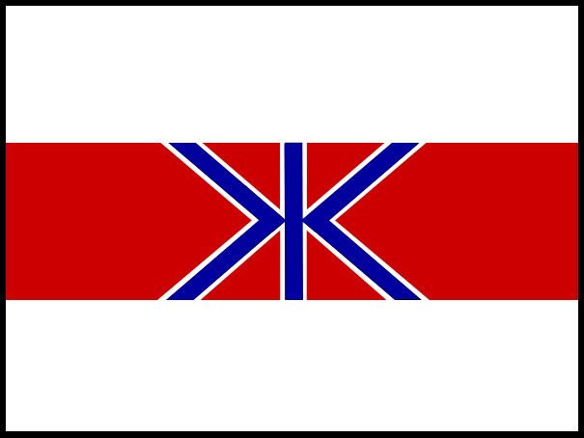
FISHERIES AGENCY
MINISTRY OF AGRICULTURE, FORESTRY AND FISHERIES, GOVERNMENT OF JAPAN

MEDIA RELEASE
19 June 2006 – St Kitts and Nevis

IWC MEMBERS BEGIN NORMALIZATION PROCESS

The Government of Japan today convened a meeting with concerned IWC members to begin the process of normalizing the International Whaling Commission.

Nations unhappy at the continued polarization of the Whaling Commission met separately from the formal proceedings to decide on a time and place to start the reformation process.

Today’s meeting arose from Japan’s statement put to the IWC earlier that expressed concern over the current dysfunction of the organization and that without reform it would lose its raison d’etre as a resource management organization. Almost 40 member nations from the IWC attended the meeting.

Japan’s Alternate Commissioner to the IWC, Joji Morishita, said that with almost 40 nations attending the meeting there were sufficient present to indicate the majority of members were in favour of beginning a process to reform the IWC.

“It’s time to bring this organisation back to its major purpose of managing commercial whaling and not continue with endless, futile discussions,” Mr Morishita said.

“To do nothing and allow the current political stalemate to continue will mean the IWC will go nowhere and break down. Japan has invested too much time, money and energy over more than 20 years to allow that to happen and that’s why it is embarking on this normalization process.”

“We believe that those members who want to continue in the IWC in good faith and abide by the spirit of the convention can do so by accepting conservation and management measures to allow controlled and sustainable whaling,” Mr Morishita said.

A meeting will be held in Japan in January / February 2007 to formulate ways to move the IWC forward.

Those who today’s meeting in St Kitts were: Antigua and Barbuda, Australia, Austria, Benin, Cameroon, Cambodia, Cote Divoire, Denmark, Dominica, Finland, Gabon, the Gambia, Germany, Grenada, Guinea, Iceland, Israel, Japan, Korea, Mali, Mauritania, Mongolia, Morocco, Netherlands, New Zealand, Nicaragua, Norway, Russian Federation, St Kitts and Nevis, St Lucia, St Vincent and the Grenadines, Senegal, South Africa, Surinam, Togo, United Kingdom, USA,

ENDS

For more information, contact Japan Delegation media adviser
Glenn Inwood +1 869 764 4301

