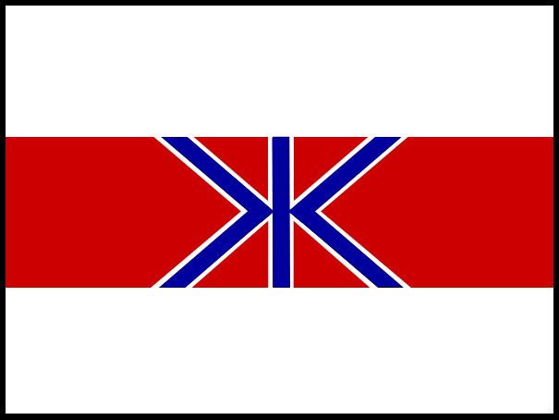
FISHERIES AGENCY
MINISTRY OF AGRICULTURE, FORESTRY AND FISHERIES, GOVERNMENT OF JAPAN

MEDIA RELEASE
18 June 2006 – St Kitts and Nevis

WHALING COMMISSION CONDEMNS MORATORIUM

In an historic vote, the International Whaling Commission today confirmed the moratorium on commercial whaling was no longer necessary and that conservation and management measures allowing for controlled and sustainable whaling must be implemented to keep the organisation relevant.

The St Kitts and Nevis Declaration was presented by the host Government and passed by the majority of members at the IWC. The declaration reiterates the organization has failed to meet its obligations under the terms of the International Convention for the Regulation of Whaling (ICRW).

Japan’s Commissioner, Mr Minoru Morimoto, congratulated the Government of St Kitts and Nevis on achieving an historic victory.

“Japan congratulates the Government of St Kitts and Nevis on this win. The declaration provides added weight to Japan’s proposal to normalize the IWC and bring it back to its original function of managing and regulating sustainable commercial whaling,” he said.

“This is but one vote. While it is a victory, the IWC remains polarized and unable to make significant resource management decisions because they require a 75 percent majority.”

“However, the St Kitts declaration adds weight to our view that this organisation needs to be reformed and brought back on track to its original mandate. This is not the end, it is the beginning. It is the beginning of securing the IWC as a resource management organization again.”

Mr Morimoto said there are IWC member nations who want to talk and move through the current political impasse. “We issue an invitation to join the normalization process. Let’s work together to bring the IWC back on track to deliver sustainable whaling,” Mr Morimoto said.

ENDS

For more information, contact Japan Delegation media adviser
Glenn Inwood +1 869 764 4301

