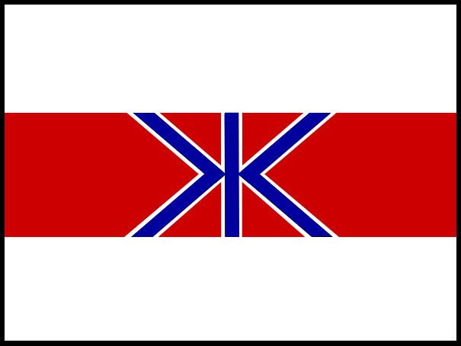
FISHERIES AGENCY
MINISTRY OF AGRICULTURE, FORESTRY AND FISHERIES, GOVERNMENT OF JAPAN

2-1, 1-Chome, Kasumigaseki, Chiyoda-ku, Tokyo 100, Japan TEL:03-3502-8111 EXT:

OPENING STATEMENT OF JAPAN
59th ANNUAL MEETING

INTERNATIONAL WHALING COMMISSION

The Government of Japan expresses its appreciation to the Government of the United States for hosting the 59th Annual Meeting of the IWC and for the hospitality we have received.

The IWC meetings could be characterized as spending time and energy, exchanging irreconcilably polarized views on almost all issues including the interpretation of the International Convention for the Regulation of Whaling (ICRW). The IWC has lost its purpose as an organization responsible for the conservation and management of whales. Greatly concerned about the real possibility of a collapse of the IWC, Japan hosted a conference on Normalization of the IWC in February of this year.

Details of the conference outcomes are recorded in the Summary Report prepared by the Chair of the conference which has been distributed as document IWC/59/7.

Japan and other IWC members who participated in the Conference would like to see changes in what has become the IWC’s institutionalized discourse of conflict and in way the IWC does its business. We believe that less confrontation, mutual respect, the building of trust and doing more by consensus can bring the IWC back to its mandated functions so that all benefit from their membership in the organization.

This is the normal course for international organizations where respect for international law, science-based management and cultural diversity is the global standard. The IWC should not remain an anomaly and we are convinced that the IWC can only be saved from its current crisis by respecting and interpreting the ICRW in good faith. Our participation at this 59th Annual Meeting will reflect these goals. We hope that other members will join us in a new spirit of cooperation. In the end, such an approach is the only means to ensure the continuation of the organization.

The 59th Annual Meeting of the IWC is an important meeting for the people and communities that receive a quota for their whaling under the IWC’s aboriginal/subsistence whaling regime. These quotas are provided on the basis of cultural and traditional use of whales for food. For similar reasons, Japan has been requesting a catch quota of minke whales from the Okhotsk Sea-West Pacific Stock for its small type coastal whaling (STCW) communities for about twenty years. This year, Japan will make another STCW catch quota proposal that it is substantially different in character from past proposals. We hope that this proposal will be fairly judged on its own merits.

The proposed schedule amendment provides that “the meat and products are to be used exclusively for local consumption”. This provision is identical with that of aboriginal subsistence whaling allowed by the IWC under paragraph 13 of the Schedule. Adoption of the proposal would allow community-based whaling in order to reinstate traditional and local practices associated with catching, processing, distribution and consumption of whale meat, and revitalize traditional festivals and rituals of the regions.

In order to ensure that whaling activities will be well managed, extensive monitoring, compliance and surveillance measures including most of the measures discussed during the RMS process will be introduced. For the purpose of securing transparency, an Oversight Committee will be established to review the results of implementing monitoring and control measures. Further, Japan’s STCW proposal has been submitted to the IWC Scientific Committee for scientific scrutiny.

While Japan’s opposition to the moratorium on commercial whaling remains firm, it should also be noted that this proposal is not requesting the lifting of the moratorium (paragraph 10 (e) of the Schedule).

We are confident that this proposal is reasonable and one which can be accepted by many IWC members. As Japan is showing the maximum compromise in this proposal, we ask that it be considered objectively and favourably. Japan believes that the fate of this proposal will test whether the IWC can be revived as a responsible international organization.

Finally, we would like to reiterate our view that the use of cetaceans, like other fishery resources, contributes to sustainable coastal communities, sustainable livelihoods, food security and poverty reduction. Whales should be treated as any other marine living resources available for harvesting subject to conservation and science-based management. Scientifically and legally, there is no reason to treat cetaceans differently.
We know that not all members of the IWC share this view but that should not prevent us from making the IWC a properly functioning organization. We look forward to working with all delegations to achieve successful outcomes for all members.

